Press Kit
Friuli Venezia Giulia
Italy

Friuli Venezia Giulia, Ippolito Nievo’s
little compendium of the universe

If the aim of an extended Europe is to be united in diversity, then Friuli Venezia Giulia has got there before it. In a place where the Alps and the Adriatic Sea symbolise the two extremes of a multi-faceted and changing landscape, the Italian, Slavic and German cultures meet in a sort of melting pot of traditions, languages and religions.
Nearly 8,000 square km of unspoilt mountains, gentle hills and deep blue sea form the contours of a nerve centre of European geography at the crossroad of people and history, a land that rewards the visitor with its richness and that never fails to surprise, no matter what the point of view is.



DISCOVER FRIULI VENEZIA GIULIA !

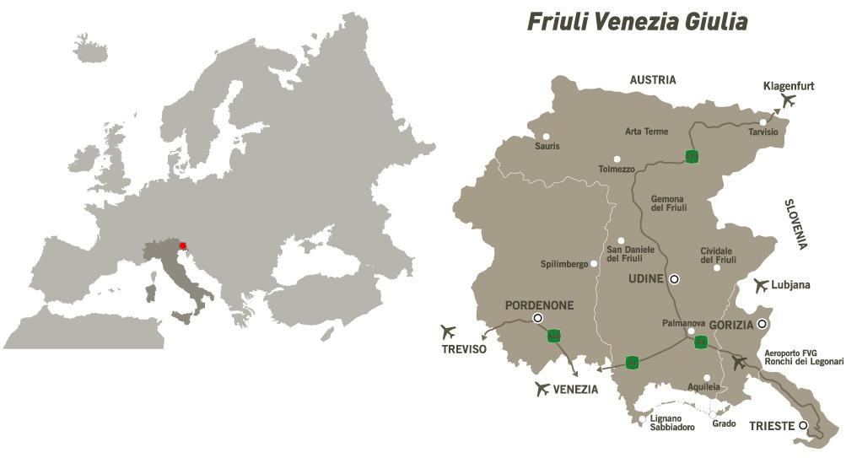

Index

- Sea
A sea of well-being for the whole family

- Winter in the mountains
The freedom of skiing without stress

- Cities of art
Jewels of art

- Food and wine
Natural tastes and aromas

- Rural tourism – Discovery and tours
Discovering the secrets of the countryside

- Summer in the mountains – parks, lagoons and nature reserves – activity tourism
Nature at its purest

- History
Living history

- Golf
A golfer’s paradise

- Spa and wellness centres
Wellbeing for body and soul

- Marine tourism
Wind and sea: a powerful combination

- Meeting Industry
High quality congresses and meetings

- Events
LIVE FriuLI VEnezia Giulia events 2011

- Fact sheet

Sea

A sea of well-being for the whole family
A coast outlined by golden sands and chalk white cliffs

From the golden beaches of Lignano and Grado, with their shallow and sandy seabeds, to the rocky inlets of the Duino nature reserve, where vertical cliffs plunge straight into the waves. Relaxation, safe and fun, but also the charm to gain new experiences, to get close to nature, to live life to the full. Friuli Venezia Giulia’s sea contains many offers in one. It is ideal as a tourist destination for families thanks to its certified facilities and a welcome programme which has been specially created to meet the needs of the younger family members and of their parents; at the same time, the summer in Friuli Venezia Giulia throbs to the exciting beat of the glamorous Lignano Sabbiadoro; or it relaxes in the silence and serenity of Grado’s lagoon and sandbanks; or it breathes the rhythmic intonations of the fishermen in Marano Lagunare. This curve in the coastline takes in 130 km of land lapped by the Adriatic Sea, providing visitors with an array of seaside resorts.

Lignano Sabbiadoro – which Ernest Hemingway called "Italy's little Florida" – is the summer entertainment capital of the Northeast of Italy. The combination of traditional sparkling Lignano nightlife with fashionable shops and boutiques makes Lignano a favourite tourist destination for young people and shopaholics. Synonymous with 24/7 joie de vivre, Sabbiadoro, together with Lignano Pineta and Lignano Riviera creates a vibrant world of sports and health-giving activities. Together with a well-planned and lively entertainment programme, the beaches are home to swimming, windsurfing and canoeing schools, aqua gym and lessons in gentle gymnastics. The offer of accommodation facilities, which include services specially conceived for families, the wide range of entertainment opportunities which comprise six different theme parks and a Health Spa as well as the coast itself – 8 kilometres of golden sand and a calm shallow sea – make Lignano the perfect holiday destination for the whole family.

A spa town favoured as the summer resort of Austro-Hungarian Emperors: along with the natural beauty of its lagoon and an exceptional microclimate ensuring a permanently sun-drenched coast, Grado can be proud of the considerable beneficial effects of its sands and iodine-rich air. There is no chance that the town's image is often associated with its thermal baths and its thermal water park, a true jewel open to display an 85-metre ergonomic swimming pool, equipped with hydro massage, waterfalls, thermal tubs, springboards and water games. The wonderful Venetian-style town centre with its maze of narrow lanes and alleys just beckons you to take a stroll.

There is something for nature-lovers and more adventurous visitors too: the steep rugged cliffs of the Kras coast. Why not enjoy the splendid panorama as you perch high on the twisting coastal road that leads to Trieste? In summer, the whole shoreline teems with life in a swarm of small bathing establishments. The one that stands out in the city centre is Pedocin: the only beach in Europe with separate areas for men and women, a legacy of the Austro-Hungarian era.

Not to be missed
- Muggia, the only Istrian-Venetian town that is still Italian, can boast the remains of an ancient Roman settlement. The old town centre, crossed by the typical narrow alleyways, hosts one of Italy’s oldest carnivals.
- Those who like sailing can be sure of finding the perfect holiday in Friuli Venezia Giulia, with its 24 fully equipped marinas and a total of 15,000 berths.
- A visit to the Nature Reserves of Marano Lagunare and of the mouths of the river Stella offers a number of ways to learn more about nature, from open-air activities (e.g. birdwatching) to workshops inside the aquaria.

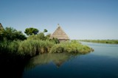 | 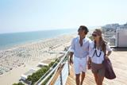 | 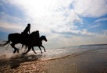 | 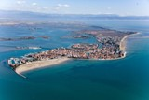
Casoni huts in the lagoon | Lignano beach | Horses on the beach | Grado, aerial view
Winter in the mountains

The freedom of borderless skiing without stress
140 km of slopes for safe and peaceful skiing

Would you like to combine skiing with the thrill of battling against the wind on a sled pulled by a team of dogs? The mushing school in Tarvisio will welcome you with open arms. Do you dream of making an entrance on the dazzling stage where the great skiing champions show what they can do? Then Ravascletto-Zoncolan will be right up your street. Would you like to plunge into a world overflowing with snow activities especially designed for young people? If you choose Piancavallo you’ll be glad you came. Wherever your fancy lies, Friuli Venezia Giulia can offer a destination to grant your wishes, offering an all-round holiday with much more than simply skiing.

Friuli Venezia Giulia means totally safe skiing without overcrowding in the five regional ski centres with about 140 kilometres of slopes. An enormous range of choices with something for everyone, no matter how well you can ski, and with guaranteed snow thanks to artificial snow-making. Another 100 kilometres of cross-country ski circuits through magical scenery provide even more variety. There are several unusual opportunities, but one is particularly rare: the chance to sleep in a true igloo village in Piancavallo. Moreover, thanks to the Alpe Adria project, you can ski in two different countries (Italy and Austria) using the same ski pass, and now it is possible to have the same charming experience between Italy and Slovenia as well. In fact, great novelty is the new link between the Friulian ski resort of Sella Nevea and the Slovenian ski resort of Bovec: unique emotions across Mount Canin for a borderless experience in Friuli Venezia Giulia. With the FVG Card, the Friuli Venezia Giulia’s destination card, even good value for money is guaranteed: card holders can use the ski-lifts to the Lussari Sanctuary and to Mount Canin free of charge, they can go walking on the snow in the Tarvisio area, in Carnia and in Piancavallo using the characteristic “ciaspe” (snowshoes) and obtain a discount when buying the multi-day ski pass.

Five resorts, a thousand things to do
- Tarvisio: 80 hectares of permanently snow-covered slopes. Make sure you don’t miss Di Prampero, an open, winding 4-kilometre course with a breath-taking view, or the Paruzzi Arena in Tarvisio Città, the cross-country skiers’ paradise. Here you can do Alpine and Nordic skiing or you could try your hand at the local mushing school. In 2011 and 2011 the resort will host the Women’s World Cup Ski championships again.
- Sella Nevea: ideal for springtime skiing thanks to its high altitude slopes between 1,200 and 2,300 metres. Permanent site of the European Cup competitions with a slalom arena that is one of the best for this sport. It hosts the Ski Centre for the Italian Skiing Federation (FIS) for competitions. Highlight: the enlargement of the skiable area by 30 km thanks to the new link with the ski resort of Bovec in Slovenia.
- Forni di Sopra: a romantic corner tucked away in the Dolomites. Snow park, sledging, ice-skating, ice-climbing make it the perfect destination for families with children.
- Ravascletto-Zoncolan: set in the wonderland of the Carnic Pre-Alps, with 60 hectares of slopes that reach an altitude of 2,000 metres. Among the various attractions available, the most outstanding is the Snow Park Free Style Arena, with a sensational cross-country trail for snowboarding and ski-cross. All this to the rhythm of music!
- Piancavallo: 50 hectares of ski slopes with a crowning achievement: a large snowpark where you can put your half pipe, jumps and rails to the test as well as a freestyle area and the fun bob, which is a bobsleigh on rails which is launched on a breath-taking descent from 1500 m altitude nose-diving on a 15% slope. Moreover, there are also alternative experiences: ski mountaineering, ice skating, “ciaspolate” (snowshoe walking), snow tubing. And for reckless people, there are arctic survival courses offered by the local school.

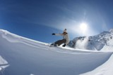 | 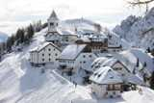 | 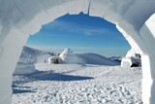 | 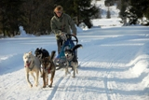
Ski slope | Santuario Monte Lussari | Igloo Village | Sleddog
Cities of art
Jewels of art
The thousand faces of art at the border between the East and the West

Elegant and decorous, proud of their beauty but never exhibitionist, the cities of Friuli Venezia Giulia travelled the globe, listened to foreign languages and met distant cultures and religions. To see this, you just need to stand in Piazza dell'Unità d'Italia and look at the Audace pier in Trieste, where the first Italian ship docked on 3rd November 1918, symbolising the annexation of Trieste to Italy, although the city had to wait until 1954 to finally become Italian; or you might choose to walk in the colourful square outside the Transalpine Railway Station in Gorizia, with one foot in Italy and the other in Slovenia. For centuries Celts, Romans, Huns, Lombards, Venetians and Austro-Hungarians passed through these places and all left an indelible mark that mingled with local traditions. Thus Trieste “dressed in Hapsburg clothes”, Udine became home of Tiepolo, Gorizia was called the “Austrian Nice” and Pordenone alternates between Roman, Baroque and Gothic influences and hosts in its province Sacile, the “Garden of the Serenissima Republic of Venice”. Discovering Friuli Venezia Giulia’s art and cultural treasures has never been easier and better value with the FVG Card, the destination card which allows holders to enter the museums in the cities of art free of charge, as well as to take part in the TurismoFVG guided tours.
After the Trieste’s primacy in 2005 and 2009, in the national list 2010 drawn up by Il Sole 24 Ore, near the regional capital as for the quality of life, are attested among the first 15 Italian cities also Gorizia and Udine.

Set in an unrivalled corner of the world, between the white of the Kras landscape and the dazzling blue of the northernmost edge of the Adriatic Sea, Trieste has always been a vital meeting point between the East and the West. The city that for centuries belonged to everyone and to no one still has the cosmopolitan, cross-border soul of a place where different cultures, languages and traditions can get together.

Udine, the elegant and convivial city, where the refinement of the architecture is linked to the rustic charm of the osterias, is the jewel-box- city of Giambattista Tiepolo, the last great painter of the Venetian school. The artist, who spent the most productive period of his career in the capital city of Friuli, left in Udine a number of masterpieces, many of which are on view in the Archiepiscopal Palace and others can be seen in the Cathedral and in the Gallery of Historic Art in the castle that overlooks the old town centre. Thanks to the visits organized by TurismoFVG, bicycles will be the most suitable means of transport to discover the artistic highlights of the town.

If Trieste reflects its ancient role as the region’s trade emporium, Gorizia has always been the real “melting pot” of Central Europe. It was here, at the crossroad of three European cultures – Latin, Slav and German - that the last fence of the Cold War between Eastern and Western Europe was torn down in 2004.

Pordenone is an elegant town that enchants with its charming old town centre, a real mosaic of 16th century palazzos, Romanesque churches, porticoes, frescoed façades, Gothic and Baroque buildings. A scroll under the prestigious arcades of the Corso or a visit to the museums or to the temporary exhibitions will let you discover the local history and culture.

Suggested visits
- Miramare Castle, fairy-tale residence of the Archduke Maximilian of Habsburg and Charlotte of Belgium.
- Take the literary trail: the streets and places that inspired great masterpieces by Italo Svevo, Umberto Saba and James Joyce.
- Explore the characteristic cafés of Trieste and enjoy an ancient Central European tradition.
- Visit the Grotta Gigante in Sgonico, the largest tourist cave in Europe (free with the FVG Card)
- Go for an unforgettable ride on the Opicina Tram, the historic cable tram dating back to 1902.
- Follow the religious routes – from the Jewish districts to the ancient traces of Islam and the Orthodox Churches – that will take you from Gorizia to Trieste, Udine, San Daniele and Gradisca.
- Gorizia’s mediaeval castle and Provincial museums. Admission free with the FVG Card.

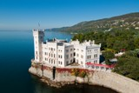 | 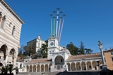 | 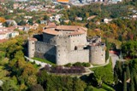 | 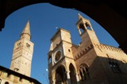
Miramare Castle – Trieste | Piazza Libertà – Udine | Mediaeval Castle - Gorizia | City Hall - Pordenone
Food and wine

Natural tastes and aromas
A kaleidoscope of flavours and 80 million bottles of top wine

From boreto a la graisana to frico friulano, by way of cjarsòns carnici. If three great culinary trends – Central European, Venetian and Slav – meet in a cuisine that is “made in Friuli Venezia Giulia”, the typical regional flavours come to the fore in a wealth of recipes guaranteed to whet any appetite. Thousands of tasty morsels from an incredible variety of terrains, environments and climactic conditions, because here the ingredients are so pure, natural and local that every dish is unique. Friuli Venezia Giulia is the ideal destination for gourmets and wine tourists, it is a land rich in tasting tours from the mountains to the seaside. Land, cuisine and history have combined to add a unique touch to the regional food and wines. The cuisine of Trieste and Gorizia falls midway between the Hapsburg and Slav traditions; that of the Carnia area is based on herbs, fruit and mushrooms, while in Friuli you can enjoy genuine and tasteful products. Nor must one forget fish and seafood, which is so abundant in this area. The coast roads are dotted with bars and small restaurants offering local dishes based on freshly caught fish and shellfish. And what can we say about Friuli Venezia Giulia’s wine production? Land of top white wines with eight DOC (Registered Designation of Origin) zones, two DOCG (Controlled origin denomination) zones and an interregional DOC zone, 1,500 vineyards producing 80 million bottles a year, with names renowned worldwide, including the two true gems, Ramandolo and Picolit. Not to forget is also the Friulano, the wine symbol of the regional territory.

Friuli Venezia Giulia certified products
Agri-foodstuff products. DOP: Montasio cheese, San Daniele ham, Tergeste extra-virgin olive oil, Salamini italiani alla Cacciatora and Julia apple; Sauris ham (IGP), smoked trout from San Daniele, grappas, honey, the Asìno cheese and the brovada. 5 regional Slow Food Presidia: the formadi frant, the garlic from Resia, radic di mont, pestât and pitina. Doc Zones: Carso, Colli Orientali del Friuli, Collio, Friuli Annia, Friuli Aquileia, Friuli Grave, Friuli Isonzo, Friuli Latisana; interregional Doc: Prosecco. Docg: COF Picolit and Ramandolo.

Typical dishes
- Trieste: jota (soup made of beans, potatoes and white cabbage), gulash, apple strudel, presnitz or cuguluf (ring-shaped pastry and cake of Viennese origin), but also large sardines breaded and fried, ribaltavapori, Trieste-style salted cod, scampi alla busara (a piquant dish with wine, onion and parsley), sarde in savôr (sweet and sour sardines). Not to be missed are the typicall bolliti (boiled meat) or a break in the osmizzas (wine-tavern) among the Kras plateau.
- Gorizia: potato gnocchi with plums drizzled with melted butter, cinnamon and a little sugar, patate in tecia (potatoes sautéed with onion), kaiserfleish (smoked pork loin scattered with grated fresh horseradish and served with sauerkraut).
- Udine: frico (crunchy delicacy based on flaked mountain cheese and potatoes), musèt e brovada (spiced pork sausage with turnips marinated in must).
- Pordenone: peta, pitina, petuccia (cured meats produced with game, ewe’s meat or mutton mixed with beef and kneaded with red wine, a pinch of salt, pepper, tubular water dropwort - known as caren in local dialect - or other herbs) and the Asìno cheese (typical of Clauzzetto, Vito d’Asio and Spilimbergo).

Dishes from the sea: boreto a la graisana (fish soup served with white polenta), squids in their own ink, sievoli sotto sal (grey mullets preserved in salt for two or three months).

Dishes from the mountains: cjarsòns (ravioli with a contrasting sweet and savoury filling), savôrs (a special dish of chopped vegetables). Worth trying too is sot la trape (a particular kind of cheese marinated in marc).

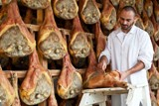 | 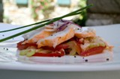 | 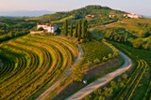 | 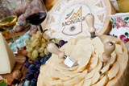
San Daniele hams | Fish fry | Vineyards | Montasio cheese

Rural tourism
Discovery&tours
Discovering the secrets of the countryside
Rural villages, local products and ancient crafts for a holiday that will never bore you

For those who are curious, for those who are particularly dynamic, for anyone who wants to pack a multitude of experiences into a single holiday, this is the place to go to, in a territory crossable North-South and East-West in an hour of driving. The wealth of different landscapes and microclimates captured between the mountains and the sea is complemented by a full programme of events and endless opportunities to satisfy your taste for exploration. There is a whole world to discover that will tempt your fancy: food and wine tours, crafts that have never been lost, archaeological remains, rural and mediaeval villages, hidden castles, waterside tracks and ancient mills, historical re-enactments, timeless rituals, even witches’ paths. Moreover, the discovery itineraries are easier and even better value with the FVG Card, Friuli Venezia Giulia’s destination card, which offers a wide range of discounts and free entries to be used on the services and tourist attractions throughout the region.

Friuli Venezia Giulia has its own special kind of hospitality, too. A wide range of alternative accommodation facilities enables to plunge into authentic rural life. For instance, you might choose to stay in one of the Alpine shepherds’ huts, with the chance to lend a hand with cheese-making; or you might like to stay on one of the holiday farms. Amongst the alternative forms of accommodation we can find bed&breakfasts as well as the albergo diffuso – a type of accommodation first launched in Friuli Venezia Giulia – that lets you combine the service of a hotel with the freedom of a holiday apartment. Visitors stay in ancient houses in small towns or villages, which have been perfectly restored, decorated and equipped in the typical mountain tradition, but with access to all the services of a hotel, all this at extremely competitive prices.

Places and traditions worth discovering
- Aquileia, a metropolis in the days of the Roman Empire, is a real open-air archaeological museum, present in the UNESCO World Heritage Site list.
- Spilimbergo, the capital of mosaic art. It offers courses at the prestigious Mosaic School of Friuli.
- Sacile, the “garden of the Republic of Venice”, split between two islands linked by bridges and canals.
- Palmanova, the “ideal city” enclosed by a 9-pointed star fortifications, that only Napoleon could conquer.
- Villa Manin of Passariano, a well-known Venetian residence where Napoleon signed the Treaty of Campo Formio. Today it is a renowned venue for international exhibitions.
- Cividale, capital of the Lombard duchy, is the leader in the inter-regional project to include Lombard sites throughout Italy in the UNESCO World Heritage Sites list.
- Poffabro, Cordovado, Fagagna, Clauiano, Gradisca d’Isonzo and Valvasone are included among the most beautiful Italian hamlets.
- Forni di Sopra, Raveo, Sauris, Sutrio, Ampezzo, Camino al Tagliamento, Comeglians, Erto e Casso, Lauco, Ovaro, Prato Carnico, Preone, Ravascletto e Socchieve are included among the net “Borghi autentici d’Italia” (autentic town of Italy), places where you could experience genuine feelings.
- Val Resia, where language and traditions have remained unchanged for almost fifteen centuries.
- The castles of Friuli’s hill district, steeped in history and strewn with ancient manors.

Connoisseurs corner
- Osmizas hunt in Kras plateau: private houses of winemakers, where is possible to taste typical local dishes (own production). How to find them? Keep your eyes on the branch (frasca)!
- Test your palate on a food and wine tasting tour.
- Sauris, a small resort of Bavarian origin, is now a landmark for gourmets. Don’t miss the famous home-brewed beer, the smoked ham, the local cheese (soft or mature varieties) and butter.
- San Daniele, the home of prosciutto (cured ham) with a claim to the largest number of tasting centres in Italy. The town’s splendid historic centre includes the oldest public library in Italy.
- Typical delicacies from Cividale: Friuli salami flavoured with garlic, or cooked in vinegar with onion, and gubana, a pastry made to an ancient recipe, with a filling of dried fruit, candied peel, and spices.
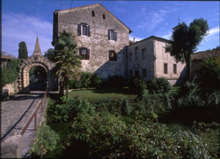 | 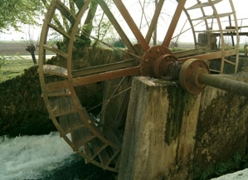 | 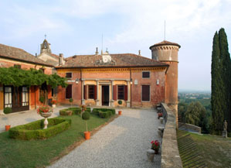 | 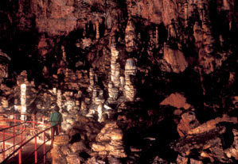
Strassoldo Castle | Millwheel close-up | Rocca Bernarda | Giant Cave
Summer in the mountains

Parks, lagoons and nature reserve

Activity tourism

Nature at its purest
16,000 hectares of lagoons, 3 nature parks and 13 conservation areas
in an unspoilt natural world

Friuli Venezia Giulia will show you what it’s really like to be in protected, unpolluted surroundings. There’s not just one, but many places where time seems to have stood still: nature parks, lagoons, conservation areas, mountains where silence reigns supreme. If you long to be totally immersed in nature, then Friuli Venezia Giulia is exactly the right place for you.

The perfect peaks reaching skyward from the Friuli Dolomites, which have recently been included in the list of UNESCO World Heritage Sites, and the Julian and Carnic Alps form the ideal frame for the lush green valleys in between. Acting as the region’s natural frontiers, the Alpine chains preserve pearls of rare beauty, such as Sauris, a symbol of the excellent food and wines of Friuli, or the Resia Valley, where the language and traditions of an ancient Slavic race have survived in an uncontaminated environment since the 7th century. Or the Tarvisio area, where three natural and cultural borders meet and enclose startling summits that climbers from all over Europe long to conquer. But if you descend from the mountains to the sea you will discover Grado and Marano Lagoons, a splendid landscape teeming with biodiversity, a stretch of 16,000 hectares, where it is possible to find the casoni: simple shelters that in the past were used by the lagoon fishermen. For those who love all forms of nature, Friuli Venezia Giulia offers 3 Nature parks, over twenty types of habitats and 13 conservation areas.

From a rushing, tumbling mountain stream to the unhurried thrill of a climb, there’s always a new emotion to stir you. In Friuli Venezia Giulia nature and sport are two inseparable words. If you’re someone who’s always on the go, FVG is your launch pad to rock climbing, trekking, mountain climbing, paragliding, gliding, mountain biking, horse riding. In fact, there are many facilities equipped with manège from which one can leave for a ride along itineraries conceived to discover the most charming places of the region riding one’s horse. For two-wheel lovers, TurismoFVG offers a rich carnet of itineraries both for road bike and MTB. With the FVG Card you can also take part in summer and winter guided tours which are free of charge. Using the destination card, holders can travel on maritime transport in Grado and Lignano with a 30% discount.

Not to be missed
- Fusine Lakes, superb expanses of water set in the kingdom of deers, roebucks, lynxes and bears.
- The Tarvisio area, where you can combine local cuisine, extreme sports and nail-biting excursions.
- Carnia, an enchanted area of pastures, age-old woods and ancient crafts.
- The sandbanks, peculiar tongues of sand emerging from the lagoons in Grado and Marano.
- Miramare Marine Reserve, the oldest in Italy, where you can go diving with a guide.
- Barcis Lake and the Campanile di Val Montanaja, the symbol of mountaineering.

Sport and discovery in a nutshell
- By bike along the regional itineraries.
- A trekking tour of the Alpine shepherds’ huts connected by trails which suit various levels of ability.
- Birdwatching in the Grado and Marano lagoons. From the thatched stone houses to the protected reserves, you’ll find a whole avian world: 320 different species amounting, at certain periods of the year, to as many as 100,000 birds.
- The Tarzan Trail or Treetop Walk, an adventure possible in various regional locations, across tracks on the trees, sky-high walkways, rope bridges, lianas and pulleys.
- Valcellina is the realm of the most unusual sports. In Claut, besides the ice rink and curling rink, you simply cannot miss the Ice-park with its vast climbing mountain made of ice. In this area you can also enjoy snowshoe walks.
- The Bridleways of the Cormor Valley, 30 kilometres of dirt tracks across the countryside.
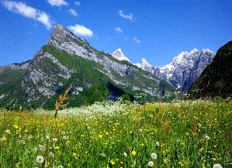 | 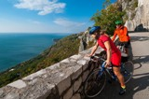 | 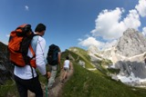 | 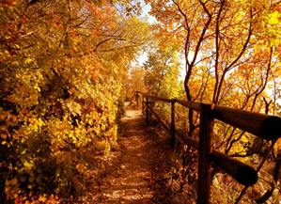
Piancavallo | Cycling tour | Trekking | Autumn path
History

Living history
From the Ancient Romans to the Cold War: history was made here

Put yourself in the shoes of a legionary on watch among the pillars of the Roman forum, brandish a double-edged sword left behind on the battlefield by the Lombards, discover traces of the Cold War’s Iron Curtain. Or walk along paths trodden by a young German officer called Rommel, crawl among the trenches that inspired the poet Giuseppe Ungaretti and search for the dungeons of a fortress in the midst of powder magazines, gun batteries and tunnels. In a region peppered with battlefields and places where history was made, the past is truly in the air.

Friuli Venezia Giulia is deep in the heart of Europe, but it is also open to the Adriatic. Its strategic position has often made it the centre of great conflicts and the site of some of the most significant moments in history. It was here that the ancient Romans built the fourth town of Europe, Aquileia. The Lombards, who were at one and the same time warriors and craftsmen, horsemen and goldsmiths, shaped the land and built a metropolis called Forum lulii – now Cividale – from which the name Friuli is derived. Later, the area became the favourite playground of the Hapsburg Empire. In more recent times, some of the most crucial episodes of the First World War took place in Friuli Venezia Giulia.

World War I
The bloody battles of the Great War branded this region with fire. It was not only a frontier, but also the deciding factor in Italy’s victory or defeat. From Carnia to Isontino, from the valleys of Natisone to the Trieste area of Carso, Friuli Venezia Giulia is an enormous open-air war museum. It is no chance that Udine was the military capital of Italy from 1915 to 1918. There are many historic sites that will stir your emotions, like the Memorial in Redipuglia, where the remains of 100,000 soldiers who fell in the war are laid to rest, or the Museum of the Great War in Gorizia. Then, too, there is a full series of events and thematic programmes, varying from historic reconstructions to tours exploring places of interest.

Historic heritage
Thanks to its encounters with the races and cultures that have crossed its territory, Friuli Venezia Giulia offers a tapestry of places and historic remains of immeasurable value. For example, the Lombard temple in Cividale, or the art treasures of Aquileia – a UNESCO World Heritage archaeological site – including the mosaic floor in the basilica, the largest in Europe, and Venzone, a fortified town, which has been declared a national monument.

Not to be missed

- The Great War Theme Park: open-air museum in Monfalcone.
- Osoppo and the Great War Museum of Ragogna: for connoisseurs. Admission free for FVG Card holders.
- The War Memorial at Redipuglia, a huge monument that looks like an army on parade, where the remains of 100,000 soldiers who fell during the war are laid to rest..
- The Risiera di San Sabba, was a Nazi concentration camp in Trieste, now is a National Monument.
- The Foiba di Basovizza, National Monument symbol of all the atrocities perpetrated at the end of WW2 by Yugoslav partisans.
- The impressive Tagliamento line of defence, scattered with ruins and blockhouses.
- Alpe Adria Militaria, an exhibition of historical-military objects.

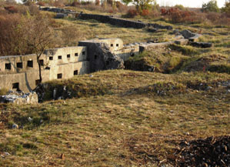 | 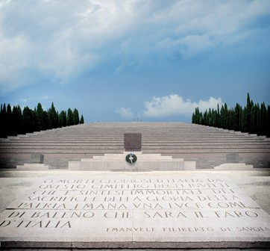 | 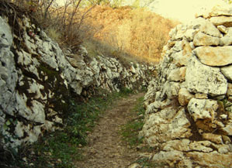 | 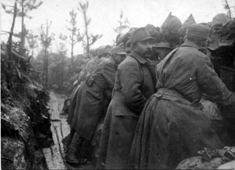
Fortifications | War Memorial in Redipuglia | Trench | Archive photo
Golf
A golfer’s paradise
7 courses with 18 holes. Play your way from the mountains right down to the sea!

Seven courses nestling in the midst of beautiful scenery, surrounded by ever-changing but still totally unspoilt nature in a climate that's gentle in every season. From the water-rimmed greens in Grado and Lignano, to the wooded mountains in Tarvisio, from the gentle slopes of the hill district to the vineyards and castles around Gorizia. No matter which course you choose, golf in Friuli Venezia Giulia has the extraordinary flavour of exploration and challenge.

In a region where mountains, sea and hills cluster together in just over 100 km, the 7 golf courses and the 9-holes one evenly distributed across the whole area enable you to immerse yourself in an abundant variety of incredibly beautiful natural settings. Friuli Venezia Giulia is also the leader of the multi-regional Italy golf&more project, a golf promotion programme among seven regions (Lombardy, Piedmont, Liguria, Emilia Romagna, Sicily, Apulia and Friuli Venezia Giulia) whose aim is to make the golf circuits even more attractive, by combining sport with other activities, such as food and wine related tours, guided visits to towns famous for their art, excursions, horse-riding, rural tourism and much more.

- Lignano Golf Club: 18 holes (6,301 m, par 72), studded with lakes and bunkers but suitable for all. Practice range with 9 covered tees, putting green, pitching green, guestrooms, pro-shop, changing rooms, bar, restaurant, hotel, electric golf carts, gym, beauty parlour.

- Grado Golf Club: 18 holes (5,746 m, par 72), famous for the many water obstacles and the lagoon in the background. The club, situated on the splendid Primero Estate, has chipping and putting greens, driving range with 12 covered tees, pro-shop, golf bag and trolley hire, clubhouse, bar, restaurant and changing rooms.

- Trieste Golf Club: 18 holes (5,810 m, par 70), a course with level-seeming but tricky greens and an unpredictable wind called bora. The clubhouse is equipped with changing rooms, video room, green tables, bar and a highly recommended restaurant. The club also has a driving range with 10 covered tees, a pitching green and a putting green.

- Castello di Spessa Golf Country Club: 18 holes (5,540 m, par 70), deep in the rustic scenery of the Collio vineyards, is provided with a Club House, changing rooms, a floodlit practice range, pro shop.

- Udine Golf Club: 18 holes (6,088 m, par 72), for a course designed by the shady cherry trees and the gently rounded hills. The adjacent clubhouse has bar, tea-room, restaurant, TV and meeting lounge, pro-shop, changing rooms, golf school and a practice range.

- Castel d’Aviano Golf Club: 18 holes (5,980 m, par 72) in the midst of centuries-old parkland. Equipped with bar, restaurant, pro-shop, tennis court.

- Tarvisio Golf Country Club: 18 holes (5,693 m, par 69) designed by the well-known Canadian architect Graham Cooke. Wide fairways on the Alpine plateau, spacious greens and treacherous bunkers. Bar, restaurant, changing rooms, driving range with covered tees, putting green, chipping green, practice bunkers, trolley hire, five-a-side football pitch, baby-sitting service, heliport, riding school.

  - Friuli Golf Club: 9 holes (1,489 m, par 30), great for those who like to get started. Driving range, pitching & putting greens, bunkers, floodlit course and putting green, clubhouse, bar, restaurant, guestrooms, pro-shop, swimming pool, tennis court.

 | 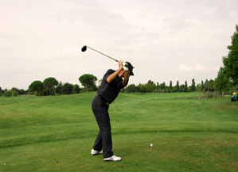 | 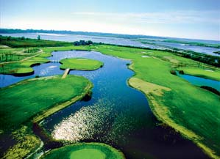 | 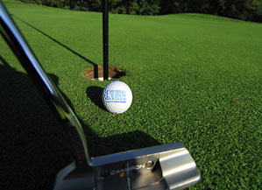
Castello di Spessa Golf Club | Taking a swing | Grado Golf Club | Close-up
Spa and wellness centres

Wellbeing for body and soul
Rejuvenate yourself like the Emperors did

By choosing Friuli Venezia Giulia you have the chance to immerse yourself in an oasis of wellness and body care. By combining centuries-old traditions of thermal baths and herbal skills with a vast range of innovative techniques, the region’s three spa centres promise to transform your holiday into a relaxing and rejuvenating experience such as you’ve never experienced before. Moreover, with the FVG Card, aesthetic and beauty treatments offered by the Grado and Lignano health spas are discounted by 30%.

The ancient Romans were the first to discover the healing effects of the mineral waters that supply the Arta Spa (Udine) from Pudia source. The spa’s location in the midst of unpolluted nature and the mild mountain climate are particularly favourable to renewing exhausted energy and, at a low altitude (only 420 metres above sea level), Arta has pure, balsamic air: the best possible combination of conditions for a healthy holiday. The curative powers of this precious source are perfect to combat respiratory affections, liver and skin diseases, arthritis and arthrosis. While Arta awaits completion of its third pavilion – which will house an extensive wellness centre with pool, sauna and relaxation area – the Aquadea Wellness Centre is open for you to enjoy: a large complex with beauty, slimming, wellness, aesthetic medicine, solarium and holistic aroma therapy sections.

Saline and thermal waters and sand baths are the strong points of the Wellness Centre in Grado – the most fashionable spa resort during the Hapsburg Empire - famed for the extraordinarily beneficial properties of the available natural elements. Rich in micro-organisms and mineral salts, Grado sands are a panacea for all kinds of rheumatic illnesses, problems with the joints, and an aid to rehabilitation. But there is far more than sand. The jewel in the crown of this vanguard structure is the Spa Water Park, which offers FVG Card holders a discount of 25% on entrance fees. The facility allows guests to use the thermal water swimming pool with hydro massage and cascade jet to tone up your body, as well as games, spring boards and a bar service within the swimming pool area.

In another seaside location, but deep in age-old pinewoods facing the Adriatic, the Lignano Sabbiadoro Spa Centre is housed in an ultra-modern building with all the advantages of progressive thalassotherapeutic techniques and the beneficial properties of the sun-and-water formula. These seawater-based treatments are ideal for treating arthritis and, by means of nebulization, ailments of the respiratory system. The centre also has a celebrated beauty centre which offers initial checkups and personalised courses of treatment to combat and eliminate cellulite, stress and weight problems by applying methods that combine body care with the pleasure of being pampered.

Showcase on wellness

- Health: sand baths, thalassotherapy, balneotherapy, ozonized baths, water massage, solarium, inhalatory cures, kinesitherapy, mekhydro (ozone + hydro massage), colour therapy... and don't forget to try the new, Hydrocare heated waterbeds.
- Beauty: besides the usual treatments (facial cleansing and care, depilation, drainage, anti-cellulite), the region’s centres offer skin checks, personalised slimming programmes, glycolic acid peelings, mesotherapy, reflexology, panthermal regeneration, lymphatic drainage and biostimulation.
- Wellness: Shiatsu, Thai, and Ayurvedic massage, aroma therapy, holistic massage, light baths, special water, stone and Tuina massages.

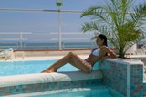 | 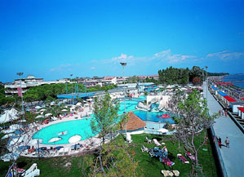 |  | 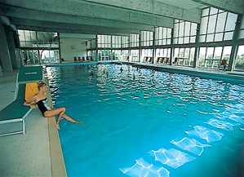
A picture of good health | Grado Water Park | The spa in Arta Terme | Swimming pool

Marine tourism

Wind and sea: a powerful combination
Where the bora blows: 130 km of coast, 24 marinas, 15,000 berths and 100 nautical events

From the mouth of the Tagliamento to the marina of Porto San Rocco in Muggia, via long sandy beaches and the splendid Grado and Lignano lagoons, all the way to the Gulf of Trieste which has one of the most intriguing rocky shoreline in the Adriatic, Friuli Venezia Giulia stretches for a whole 130 km along the coast. If, on the other hand, you prefer the open sea, the region’s 24 marinas and the other 20 locations (e.g. sailing associations, docks and small ports) offer you a total number of berths which is among the highest in the Mediterranean basin, and makes this the ideal starting point for any kind of boat trip.

Friuli Venezia Giulia is the perfect destination for those who love the sea. Tourist or yachtsman, beginner or old salt, when you arrive in this region you will find a properly organised system with the highest quality standards at your service. Friuli Venezia Giulia can accommodate as many as 15,000 berths and provides fully equipped moorings for boats of all sizes, backed by all the associated services and specialised boatyards. A network of businesses and craftsmen dedicated to boat-building and to repairing all types of craft, from large cruisers to high-performance hulls, right down to very small boats, is ready to assist boat-lovers who want to venture onto seas frequented by the most famous skippers who ever navigated the globe.
Moreover, all over the year over 100 important nautical events take place in the region.

Nautical events not to be missed

- International Three Gulfs Week – Sailing events and entertainments take place in Muggia and in the Gulfs of Izola and Portoroz in Slovenia. The week includes the “borderless” Muggia-Portoroz-Muggia regatta between Italy and Slovenia.

- Barcolana - Autumn Cup – On the second Sunday of October the Gulf of Trieste becomes the stage for the world’s largest regatta (from the point of view of the number of participants). A spectacle that fills the gulf with 2,000 boats of all sizes, from hi-tech hulls to the tiniest sailing boats. www.barcolana.it

- Nautilia – Second hand Boat Show – This event takes place in Aprilia Marittima di Latisana at the end of October. The special feature of this show is that the boats are in dry dock; the event brings together over 15,000 visitors and dozens of boat dealers from Italy and abroad. www.nautilia.org

- Graisana – Two events in one: on the one hand, the traditional regatta, on the other a date for your yachting diary. The two are linked by a rich programme of cultural happenings, food and wine-tasting.

- Barcamania – an event devoted to leisure boating that takes place in March in Lignano Pineta. www.barcamania.org

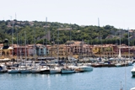 | 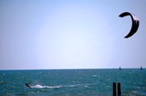 | 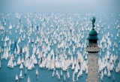 | 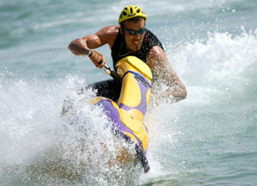
Porto San Rocco – Muggia | Kitesurf | Barcolana | Jet ski

Meeting industry

High quality congresses and meetings
Dream locations certified by Federcongressi standards

When you arrive in Friuli Venezia Giulia you are in the heart of Europe. Thanks to its strategic position, in the centre of the Old Continent, every event can become a unique occasion and a guaranteed success. This easily accessible region served by Trieste airport, just an hour from the international hubs of Venice and Ljubljana, is the ideal destination for conference tourism.

Friuli Venezia Giulia offers a wide choice of first-class, well-equipped locations for hosting conferences, meetings and workshops of various kinds and sizes all over the region. Professional activities can be combined with a programme of excursions, entertainment, leisure and shopping, cultural or food and wine related visits, thanks to the beauty of an area whose varied landscape – from the Adriatic sea to the Alps, from the cities of art to the hilly country side – is a perfect setting, whatever your requirements.

The consulting service by TurismoFVG is completely free. It provides companies, associations, meeting planners and PCOs with quality services offered by the region for the organization of events and for the acquisition and organization of conferences.

The main conference centre is Trieste, which was granted status as an international centre of attraction by the European Federation of Conference Towns, and that offers top-level and state-of-art congress venues, access to excellent hotel facilities and a proven track record of over twenty years’ experience. In Trieste, the flagship is the Stazione Marittima Congress Palace (floor space of over 2,000 m² with 980 seats, 6 rooms with advanced technical equipment for scientific sessions, 5 rooms for parallel sessions and 400 m² of exhibition space), lapped on three sides by the sea and located in the city’s cultural district. The largest multifunctional complex in the region is the Udine Expo Conference Centre (9 modern pavilions, 600 to 1,500 seats, a number of rooms adaptable into separate units, and an auditorium with 360 fixed seats). In Grado the modern Conference Hall (an auditorium with 994 seats) is ideal for large business meetings and conferences, while the Kursaal Conference Centre has a team of dedicated professionals operating in Lignano. West of the region the Pordenone Expo Conference Centre offers nine halls, able to host max 4000 people.

The Sales Guide brings together all the regional venues that have been certified according to Federcongressi parameters. The new publication which also provides a list of services connected to this field as well as a series of proposals regarding possible tours which could take place before or after the convention, is meant to be an effective and unitary tool for communicating Friuli Venezia Giulia’s strong points. The website devoted to the conference tourism in the region (www.congress.fvg.it) is even more up-to-date.

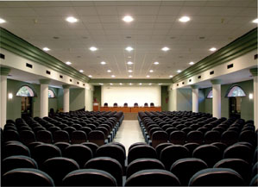 | 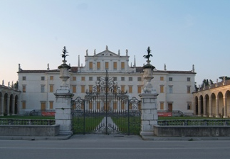 | 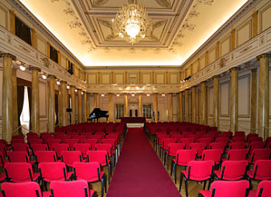 | 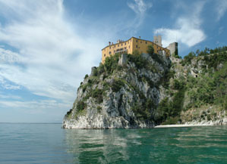
Udine Conference Centre | Villa Manin | Verdi Teather – Foyer Hall | Duino Castle

Events
FRIULI VENEZIA GIULIA events 2011

Food and wine events
- Sapori Pro Loco (Local Flavours), 14th –15th and 21st –22nd May 2011 at Villa Manin of Codroipo (Udine),
- Cantine aperte (Open wine cellars), 28th - 29th May 2011, in several locations around the region
- Aria di festa, the festival devoted to S. Daniele ham, 24th – 27th June 2011 in San Daniele del Friuli (Udine)
- Calici di stele (Goblets of Stars), 10th –14th August 2011 in several locations around the region
- Friuli Doc, September 2011 in Udine
- Pumpkin Festival, 22nd – 23rd October 2011 in Venzone (Udine)
- Ein Prosit in Tarvis (A Toast in Tarvisio), end of November – beginning of December 2011 in Tarvisio and Malborghetto (Udine)
- Flavours from Carnia, 2nd week of December 2011 in Raveo (Udine)

Cultura
- Dedica 2011 (Dedication 2011), 12th – 26th March 2011 in Pordenone
- Vicino-Lontano (Close-Far) – Terzani Prize, 12th –15th May 2011 in Udine
- E’Storia, 20th – 22nd May 2011 in Gorizia
- Topolò’s Station, 2nd – 17th July 2011 in Topolò di Grimacco (Udine)
- Pordenonelegge.it, 14th –18th September 2011 in Pordenone
- Bianco&Nero (Black&White) in Udine

Folclore
- Carnevale di Muggia (carnival) 3rd – 9th March 2011 in Muggia (Trieste)
- Crosses’ kiss, 5th June 2011 in Zuglio (Udine)
- Sagra dei Osei, 21st August 2011 in Sacile (Pordenone)

Cinema
- Trieste Film Festival, 20th – 26th January 2011 in Trieste
- Far East Film, 29th April – 7th May 2011 in Udine
- Maremetraggio, 1st – 9th July 2011 in Trieste
- Sergio Amidei Prize 14th – 23rd July 2011 in Gorizia
- Silent Film Festival, 1st – 8th October 2011 in Pordenone
- Latin-American Film Festival, October – November 2011 in Trieste
- Scienceplusfiction, November 2011 in Trieste

Music
- Vocalia – International Music Festival, 3rd and 4th weekend of May 2011 in Maniago (Pordenone)
- Fiera della Musica (Music Festival), 24th^{th} – 26th June 2011 in Azzano Decimo (Pordenone)
- Blues in Villa 1st – 3rd July 2011 in Villa Varda – Brugnera (Pordenone)
- Folkest, 1st July –1st August 2011 in various locations around the region
- No Border Music Festival, July – August 2011 in Tarvisio (Udine)
- Jon Bon Jovi, 17th July 2011 in Udine
- Udine Jazz, July 2011 in Udine
- Jazz&Wine for Peace Festival, end of October 2011 in Cormons (Gorizia)

Theater
- Mittelfest, July 2011 in Cividale del Friuli (Udine)
- International Operetta Festival, July 2011 in Trieste
- Alpe Adria Puppet Festival, August – September 2011 in Grado and Gorizia

Sport
- World Championships Ski Mountaineering 18th – 24th February 2011 in Claut (Pordenone)
- Alpine FIS Ski World Cup Ladies 5th – 6th March 2011 in Tarvisio (Udine)
- Cycling Tour of Friuli Venezia Giulia, 5th – 8th May 2011 in several locations around the region
- Bavisela (marathon), 8th May 2011 in Trieste
- Giro d’Italia (The Tour of Italy), 20th – 21st – 22nd May 2011 in several locations around the region
- Magraid, 17th –19th June 2011 in Cordenons (Pordenone)
- Rally of the Eastern Alps, 1st – 3rd September 2011, in several locations around the province of Udine
- European Masters Games, 10th – 20th September in Lignano Sabbiadoro (Udine)
- Barcolana (sailing race), 1st – 9th October 2011 in Trieste

Fact sheet

Uselful information

General Data

Friuli Venezia Giulia is an autonomous region whose autonomy was granted by a special statute in 1963. It is located in North-eastern Italy and it borders Austria to the North, Slovenia to the East, the Adriatic Sea to the South and the Veneto region to the West.

Surface area 7,856 kmq
Population 1,230.936

Population per province:

Trieste |  | 236.650 in.
Udine | 541.081 in.
Pordenone |  | 313.639 in.
Gorizia |  | 142.627 in.

Capitals of the provinces:

Trieste | 208.781 in.
Udine | 99.525 in.
Pordenone | 51.512 in.
Gorizia | 35.980 in.

Official minority languages:

Friulian (Law of 15.12.1999, No. 482, Article 3)
Slovenian (Law of 15.12.1999, No. 482, Article 3 - Law of 23.02.2001 No. 38)
German (Law of 15.12.1999, No. 482, Article 3)

2220 accommodation facilities for all needs:

Hotels |  | 716
Holiday farms and country houses |  | 260
Alberghi diffusi* |  | 12
B&B |  | 421
Hostels |  | 4
Alpine huts |  | 31
Rooms to let |  | 279
Campsites |  | 28
Tourist residences |  | 26
Tourist Villages |  | 6
Holiday apartaments |  | 352
Social services providing facilities |  | 83
Dry Marinas |  | 2
* Hotels with rooms in a number of buildings scattered around historic town centres.

